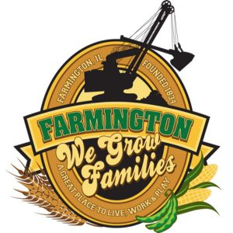
FARMINGTON CITY COUNCIL
September 2, 2025
AGENDA
CITY COUNCIL CHAMBERS
6:00 P.M.
322 E. FORT STREET, FARMINGTON IL 61531

Call to Order
Pledge of Allegiance

Roll Call:

Minutes
Regular Session: 8-18-2025

Correspondence

Bills Presented for Payment and Balance of Accounts

Police Department Report

Old Business

New Business
- Discussion/Possible Action: CEDC Recommandations
- Discussion/Possible Action : Homecoming Parade
- Discussion/Possible Action: Digitizing City Code/Ordinances
- Discussion/Possible Action: Office Safe
- Discussion/Possible Action: Spoon Rive Mussel Trail
- Discussion/Possible Action : Windows for City Building
- Discussion/Possible Action : Mayoral Appointment
- Executive Session5ILCS 120/2 (C) (21)
  - Discussion of minutes of meetings lawfully closed under this act, whether for purposes of approval by the body of minutes or semi-annual review of the minutes as mandated by Section 2.06
- Discussion/Possible Action: Action from Executive Session

Committee Reports

Finance/Ordinance: Crusen Streets/Sidewalks/Garbage: Gilles
Public Safety: Boggs Parks and Recreation: Smith
Sewer: Fleming Public Grounds and Buildings: Rose

General Comments
Adjournment

https://www.youtube.com/@cityoffarmingtonil

