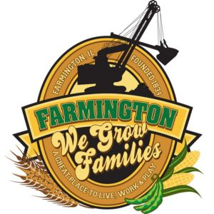
FARMINGTON CITY COUNCIL

AGENDA
CITY COUNCIL CHAMBERS
September 15, 2025
6:00 P.M.
322 E. FORT STREET, FARMINGTON IL 61531

Call to Order
Pledge of Allegiance

Roll Call

Minutes
Regular Session: 9-2-25

Correspondence

Cemetery Minutes
No meeting this month

Old Business

- None

New Business

- Discussion/Possible Action: Resolution 2025-01 2025 Multi-Jurisdictional Multi-Hazard Mitigation Plan
- Discussion/Possible Action: Farmington Community Center Gym Roof Repair
- Discussion/Possible Action: Jacobs Park/Kersh Field improvements
- Discussion/Possible Action: Reapproval of CEDC grant from FY24
- Discussion/Possible Action: Ordinance 2025-31 Intergovernmental Agreement with Township Park

Committee Reports:

Finance/Ordinance: Ald. Crusen Streets/Sidewalks/Garbage: Ald. Gilles
Public Safety: Ald. Boggs Parks and Recreation: Ald. Smith
Sewer: Ald. Fleming Public Grounds and Buildings: Ald. Rose

General Comments

Adjournment

