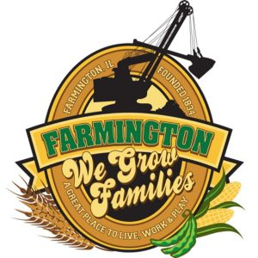
FARMINGTON CITY COUNCIL

AGENDA
CITY COUNCIL CHAMBERS
August 18, 2025
6:00 P.M.
322 E. FORT STREET, FARMINGTON IL 61531

Call to Order
Pledge of Allegiance

Roll Call

Minutes
Regular Session: 8-4-25

Correspondence

Cemetery Minutes

Admin Report

Old Business

- Discussion/Possible Action: Ordinance 2025-22

New Business

- Discussion: Elmwood YMCA Donation

Committee Reports:

Finance/Ordinance: Ald. Crusen Streets/Sidewalks/Garbage: Ald. Gilles
Public Safety: Ald. Boggs Parks and Recreation: Ald. Smith
Sewer: Ald. Fleming Public Grounds and Buildings: Ald. Rose

General Comments

Adjournment

