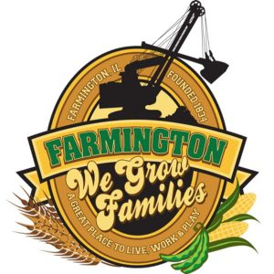
FARMINGTON CITY COUNCIL

AGENDA
CITY COUNCIL CHAMBERS
July 7, 2025
6:00 P.M.
322 E. FORT STREET, FARMINGTON IL 61531

Call to Order
Pledge of Allegiance

Roll Call:

Minutes
Regular Session: 6-16-2025

Correspondence

Bills Presented for Payment

Balance of Accounts

Police Department Report

Old Business
- First Reading: 2025-22 An Ordinance Amending Chapter 7, “Vacant and Neglected Building.”

New Business

- Discussion/Possible Action: 2025-23 An Ordinance Amending FY26 Commercial TIF
- Discussion/Possible Action: Replacement of FCC HVAC
- Discussion/Possible Action: Donation to 2025 Back to School Bash
- Discussion/Possible Action: CEDC Recommandations
- Discussion/Possible Action : Ordinance 2025-24Lefty’s Parlor Forgivable Loan Grant
- Discussion/Possible Action: Ordinance 2025-25 Amending UTV/Golf Cart Ordinance

Committee Reports

Finance/Ordinance: Crusen Streets/Sidewalks/Garbage: Gilles
Public Safety: Boggs Parks and Recreation: Smith
Sewer: Fleming Public Grounds and Buildings: Rose

General Comments
Adjournment

https://www.youtube.com/@cityoffarmingtonil

