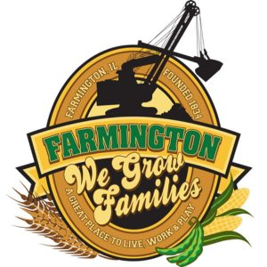
FARMINGTON CITY COUNCIL

AGENDA
CITY COUNCIL CHAMBERS
July 21, 2025
6:00 P.M.
322 E. FORT STREET, FARMINGTON IL 61531

Call to Order
Pledge of Allegiance

Roll Call

Presentation
Elmwood YMCA presentation – Andy Thorton

Minutes
Regular Session: 7-7-25

Correspondence

Cemetery Minutes

Old Business

- Discussion: Ordinance 2025-22 An Ordinance Amending Chapter 7, “Vacant and Neglected Buildings”

New Business

- Discussion/Possible Action: Redrawing Zoning Map for parcels 05-04-02-200-012 and 05-04-02-200-013
- Discussion/Possible Action: Replacing 2 Ton Truck
- Discussion/Possible Action: Moving funds from General Fund to Illinois Funds

Committee Reports:

Finance/Ordinance: Ald. Crusen Streets/Sidewalks/Garbage: Ald. Gilles
Public Safety: Ald. Boggs Parks and Recreation: Ald. Smith
Sewer: Ald. Fleming Public Grounds and Buildings: Ald. Rose

General Comments

Adjournment

