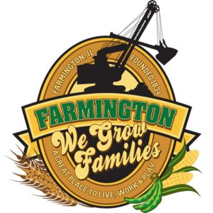
FARMINGTON CITY COUNCIL

AGENDA July 17, 2023
CITY COUNCIL CHAMBERS

7:00 P.M.
322 E. FORT STREET, FARMINGTON IL 61531

Call to Order
Pledge of Allegiance

Roll Call

Minutes
Regular Session: 7-3-23

Correspondence

Cemetery Minutes

- No meeting held

Streets Department Report

Old Business

- Discussion/Possible Action: Ordinance 2024-01 Whistle Blower Protection

New Business

- Discussion/Possible Action New Cemetery Mower

Committee Reports:

Finance/Ordinance: Ald. Crusen Streets/Sidewalks/Garbage: Ald. Gilles
Public Safety: Ald. Boggs Parks and Recreation: Ald. Smith
Sewer: Ald. Fleming Public Grounds and Buildings: Ald. Rose

General Comments

Adjournment

