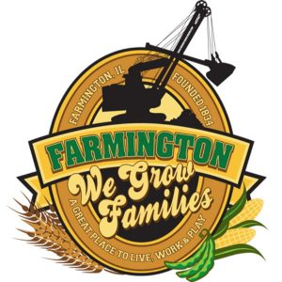
FARMINGTON CITY COUNCIL

AGENDA
CITY COUNCIL CHAMBERS
June 2, 2025
6:00 P.M.
322 E. FORT STREET, FARMINGTON IL 61531

Call to Order
Pledge of Allegiance

Roll Call:

Minutes
Regular Session: 5-19-2025

Correspondence

Bills Presented for Payment

Balance of Accounts

Police Department Report

Old Business

New Business
- Discussion/Possible Action: CEDC Recommandations
- Discussion/Possible Action : Ordinance 2025-20 An Ordinance extending the TIF agreement with Dana Cardenas
- Discussion/Possible Action: Ordinance 2025-21 An Ordinance establishing a NON-TIF Redevelopment Grant
- Discussion/Possible Action: FY2026 MFT Program – Oak Street Bids
- Discussion/Possible Action: 4th of July Parade

Committee Reports

Finance/Ordinance: Crusen Streets/Sidewalks/Garbage: Gilles
Public Safety: Boggs Parks and Recreation: Smith
Sewer: Fleming Public Grounds and Buildings: Rose

General Comments
Adjournment

