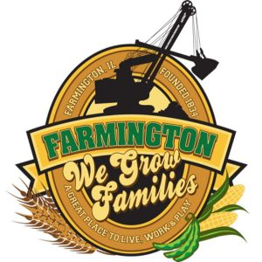
FARMINGTON CITY COUNCIL

AGENDA
CITY COUNCIL CHAMBERS
June 16, 2025
6:00 P.M.
322 E. FORT STREET, FARMINGTON IL 61531

Call to Order
Pledge of Allegiance

Roll Call

Minutes
Regular Session: 6-2-25

Correspondence
Thank you, Jordyn Atchley

Cemetery Minutes

Old Business

New Business

- Discussion/Possible Action: Purchase 165 Wall St. and Demolition
- Discussion: Ordinance 2025-22 An Ordinance amending Chapter 7, “Vacant and Neglected Buildings”
- Discussion/Possible Action: S. Fairview Road Bridge Inspection by Mauer-Stutz

Committee Reports:

Finance/Ordinance: Ald. Crusen Streets/Sidewalks/Garbage: Ald. Gilles
Public Safety: Ald. Boggs Parks and Recreation: Ald. Smith
Sewer: Ald. Fleming Public Grounds and Buildings: Ald. Rose

General Comments

Adjournment

