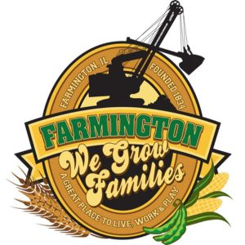
FARMINGTON CITY COUNCIL

AGENDA
CITY COUNCIL CHAMBERS
May 5, 2025
6:00 P.M.
322 E. FORT STREET, FARMINGTON IL 61531

Call to Order
Pledge of Allegiance

Roll Call:

Minutes
Regular Session: 4-21-25

Correspondence

Bills Presented for Payment

Balance of Accounts

TIF Report

Police Department Report

Old Business

Sine Dine
- Official Oath of New City Clerk and City Council People

Roll Call New Council

New Business
- Discussion/Possible Action: Recreation Budget
- Discussion/Possible Action: LJ’s Adventure Hub Beer Garden Application
- Discussion/Possible Action: Ordinance 2025-15 FY26 Commercial Façade Renovation Program
- Discussion/Possible Action: Ordinance 2025-16 FY26 Residential Rehab Program
- Discussion/Possible Action: FPD New Vehicle Purchase
- Discussion/Possible Action: Ordinance 2025-17 Past NON TIF Redevelopment Grants
- Discussion/Possible Action: CEDC Recommendations

Committee Reports

Finance/Ordinance: Crusen Streets/Sidewalks/Garbage: Gilles
Public Safety: Boggs Parks and Recreation: Smith
Sewer: Fleming Public Grounds and Buildings: Rose

General Comments
Adjournment

