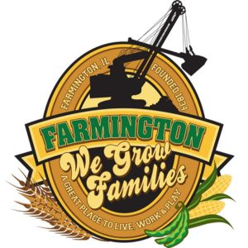
FARMINGTON CITY COUNCIL

AGENDA
CITY COUNCIL CHAMBERS
May 19, 2025
6:00 P.M.
322 E. FORT STREET, FARMINGTON IL 61531

Call to Order
Pledge of Allegiance

Roll Call

Presentation
Community Conversation – Meghan Brake

Minutes
Regular Session:

Correspondence

Cemetery Minutes

Admin Report

Old Business

New Business

- Executive Session 5 ILCS 120/2 (C) (1)
The appointment, employment, compensation, discipline, performance or dismissal, of specific employees of the public body or legal council for the public body, including hearing testimony on a complaint lodged against an employee of the public body or against legal council for the public body to determine its validity.
- Discussion/Possible Action: Ordinance 2025-18 An Ordinance Eliminating Position
- Discussion/Possible Action: Approval of Severance for Former City Administrator
- Discussion/Possible Action: Oak Street MFT program
- Discussion/Possible Action: Community Garden approval
- Discussion/Possible Action: Ordinance 2025-19 An Ordinance for Economic Development with Maggie Connel

Committee Reports:

Finance/Ordinance: Ald. Crusen Streets/Sidewalks/Garbage: Ald. Gilles
Public Safety: Ald. Boggs Parks and Recreation: Ald. Smith
Sewer: Ald. Fleming Public Grounds and Buildings: Ald. Rose

General Comments

Adjournment

