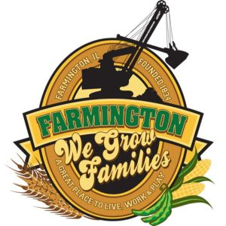
FARMINGTON CITY COUNCIL

AGENDA
CITY COUNCIL CHAMBERS
April 7, 2025
6:00 P.M.
322 E. FORT STREET, FARMINGTON IL 61531

Call to Order
Pledge of Allegiance

Roll Call:

Minutes
Regular Session: 3-17-2025

Correspondence
St. Jude Canton to Peoria Run Donation at 4 way.

Bills Presented for Payment

Balance of Accounts

Police Department Report
- Swearing in of New Officers

Old Business
- Discussion/Possible Action: Lease between ITS and City for JFL Football Field

New Business
- Discussion/Possible Action: Sub-lease between City and JFL for the use of JFL Football Field
- Discussion/Possible Action: MFT Program for 2025
- Discussion/Possible Action: Ordinance 2025-10 CEDC Ordinance with Scott Anderson
- Discussion/Possible Action: CEDC Recommendations
- Discussion/Possible Action: Ordinance 2025-09 ORDINANCE DIRECTING SALE OF PIN 05-04-11-208-006
- Discussion/Possible Action: John Higgs Parking Lot Seal Coating
- Discussion/Possible Action: Intergovernmental Agreement with Farmington Township Park

Committee Reports

Finance/Ordinance: Crusen Streets/Sidewalks/Garbage: Gilles
Public Safety: Boggs Parks and Recreation: Smith
Sewer: Fleming Public Grounds and Buildings: Rose

General Comments
Adjournment

https://www.youtube.com/@cityoffarmingtonil

