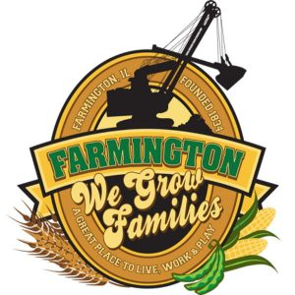
FARMINGTON CITY COUNCIL

AGENDA
CITY COUNCIL CHAMBERS
April 21, 2025
6:00 P.M.
322 E. FORT STREET, FARMINGTON IL 61531

Call to Order
Pledge of Allegiance

Roll Call

Minutes
Regular Session: 4-7-2025

Correspondence
CEDC 265

Cemetery Minutes

Admin Report

Old Business

New Business

- Executive Session 5 ILCS 120/2 (C) (1)
The appointment, employment, compensation, discipline, performance or dismissal, of specific employees of the public body or legal council for the public body, including hearing testimony on a complaint lodged against an employee of the public body or against legal council for the public body to determine its validity
- Discussion/Possible Action: Compensation increases for City Employees
- Discussion/Possible Action: Ordinance 2025-11
- Discussion/Possible Action: Street Sign Replacement
- Discussion/Possible Action: Ordinance 2025-12 TIF Redevelopment with Small Town Circus
- Discussion/Possible Action: Ordinance 2025-13 TIF Redevelopment with Sedgwick Funeral Home
- Discussion/Possible Action: Farmington Trap Shooting Team Donation
- Discussion/Possible Action: FCES Gold Outing Donation
- Discussion/Possible Action: Spoon River Valley FOP Lodge 427 Golf Outing Donation

Committee Reports:

Finance/Ordinance: Ald. Crusen Streets/Sidewalks/Garbage: Ald. Gilles
Public Safety: Ald. Boggs Parks and Recreation: Ald. Smith
Sewer: Ald. Fleming Public Grounds and Buildings: Ald. Rose

General Comments

Adjournment

https://www.youtube.com/@cityoffarmingtonil

