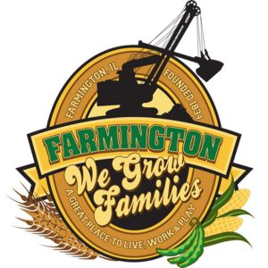
FARMINGTON CITY COUNCIL
April 15, 2024
AGENDA
CITY COUNCIL CHAMBERS

6:00 P.M.
322 E. FORT STREET, FARMINGTON IL 61531

Call to Order
Pledge of Allegiance

Roll Call

Special Announcement/Thank You – Farmington Students that Made Cemetery Gate

Minutes
Regular Session: 04/01/2024

Correspondence

Cemetery Minutes

Old Business
Discussion/Possible Action: CEDC Recommendations
- Discussion/Possible Action: FOB Entry System FCC & City Building
- Review Pool Ordinances and Pool Filling Guidelines

New Business

- Discussion/Possible Action: Intergovernmental Agreement with Township Park
- Discussion/Possible Action: Summer Recreation Program/Summer Food and Fun

Committee Reports:

Finance/Ordinance: Ald. Crusen Streets/Sidewalks/Garbage: Ald. Gilles
Public Safety: Ald. Boggs Parks and Recreation: Ald. Smith
Sewer: Ald. Fleming Public Grounds and Buildings: Ald. Rose

General Comments

Adjournment

