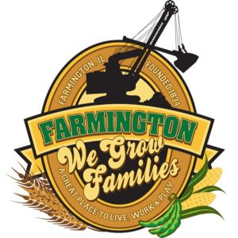
FARMINGTON CITY COUNCIL

AGENDA April 1, 2024
CITY COUNCIL CHAMBERS

6:00 P.M.
322 E. FORT STREET, FARMINGTON IL 61531

Call to Order
Pledge of Allegiance

Roll Call:

Minutes
Regular Session: March 18, 2024

Correspondence

Bills Presented for Payment

Balance of Accounts

TIF Report

Police Department Report

Old Business
Discussion/Possible Action: Flock Camera Agreement

New Business
EXCECUTIVE SESSION: 5ILCS 120/2 (C) (1):

THE APPOINTMENT, EMPLOYMENT, COMPENSATION, DISCIPLINE, PERFORMANCE OR DISMISSAL OF SPECIFIC EMPLOYEES OF THE PUBLIC BODY OR LEGAL COUNCIL FOR THE PUBLIC BODY, INCLUDING HEARING TESTIMONY ON A COMPLAINT LODGED AGAINST AN EMPLOYEE OF THE PUBLIC BODY OR AGAINST LEGAL COUNSEL FOR THE PUBLIC BODY TO DETERMINE ITS VALIDITY

Discussion/Possible Action: Action resulting from Executive Session
Discussion/Possible Action: Flooring for Administration Office and Cemetery Room
Discussion/Possible Action: 2024 MFT Program for Street Improvement
Possible Discussion/Action: Resignation of Brenda Balagna as Deputy Clerk
Possible Discussion/Action: Resolution to appoint Tracy Sollenberger as Deputy Clerk and IMRF Representative

Committee Reports

Finance/Ordinance: Crusen Streets/Sidewalks/Garbage: Gilles
Public Safety: Boggs Parks and Recreation: Smith
Sewer: Fleming Public Grounds and Buildings: Rose

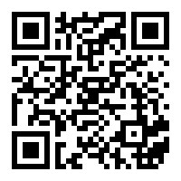
General Comments
Adjournment
https://www.youtube.com/@cityoffarmingtonil

