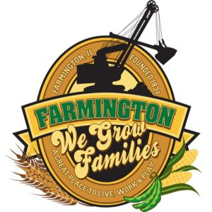
FARMINGTON CITY COUNCIL

AGENDA March 4, 2024
CITY COUNCIL CHAMBERS

6:00 P.M.
322 E. FORT STREET, FARMINGTON IL 61531

Call to Order
Pledge of Allegiance

Roll Call:

Minutes
Regular Session: February 19, 2024

Correspondence

Bills Presented for Payment

Balance of Accounts

TIF Report
Nothing to report

Police Department Report

Old Business

New Business
Possible Discussion/Action: Purchase bleachers, volleyball nets, floor scrubber from YMCA

Committee Reports

Finance/Ordinance: Crusen Streets/Sidewalks/Garbage: Gilles
Public Safety: Boggs Parks and Recreation: Smith
Sewer: Fleming Public Grounds and Buildings: Rose

General Comments
Adjournment
https://www.youtube.com/@cityoffarmingtonil

