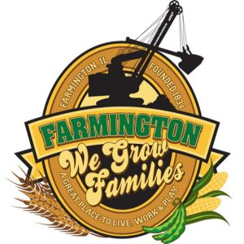
FARMINGTON CITY COUNCIL
March 18, 2024
AGENDA
CITY COUNCIL CHAMBERS

6:00 P.M.
322 E. FORT STREET, FARMINGTON IL 61531

Call to Order
Pledge of Allegiance

Roll Call

Minutes
Regular Session: 03/04/2024

Correspondence
Resignation of Officer Glover

Cemetery Minutes

Old Business

New Business

- Discussion/Possible Action: H & H Lighting for FCC
- Discussion/Possible Action: 22-23 MFT Resolution
- Discussion/Possible Action: Appointment of an Ethics Advisor for the City of Farmington
- Discussion/Possible Action: FOB Entry System for Municipal Building and Community Center
- Discussion/Possible Action: Sponsorship of FOP Golf Outing
- Discussion/Possible Action: Adding Full-Time public Works Employee

Committee Reports:

Finance/Ordinance: Ald. Crusen Streets/Sidewalks/Garbage: Ald. Gilles
Public Safety: Ald. Boggs Parks and Recreation: Ald. Smith
Sewer: Ald. Fleming Public Grounds and Buildings: Ald. Rose

General Comments

Adjournment

