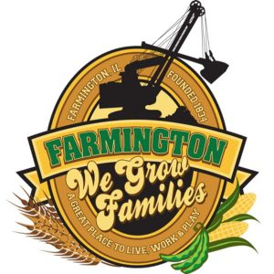
FARMINGTON CITY COUNCIL

AGENDA
CITY COUNCIL CHAMBERS
March 17, 2025
6:00 P.M.
322 E. FORT STREET, FARMINGTON IL 61531

Call to Order
Pledge of Allegiance

Roll Call

Minutes
Regular Session: 3-3-25

Correspondence

Cemetery Minutes 3-11-25

Admin Report March 2025

Old Business

New Business

- Discussion/Possible Action: 2025-07 An ordinance declaring surplus revenue in the farmington TIF District.
- Discussion/Possible Action: 2025-08 An ordinance approving and authorizing the execution of the First Amendment to the Farmington Tax Increment Financing (TIF) District Intergovernmental Agreement.
- Discussion/Possible Action: Donation to K9 Koala Egg Hunt. (April 26)
- Discussion/Possible Action: City owned property (05-04-11-208-006) on W Fort advertised for sale.

- Executive Session 5 ILCS 120/2 (c) (3)
  - The selection of a person to fill a public office, as defined in the Act, including a vacancy in a public office, when the public body is given power to appoint under law or ordinance, or the discipline, performance, or removal of the occupant of a public office, when the public body is given power to remove the occupant under law or ordinance.
- Executive Session 5 ILCS 120/2 (C) (1)
  - The appointment, employment, compensation, discipline, performance or dismissal, of specific employees of the public body or legal council for the public body, including hearing testimony on a complaint lodged against an employee of the public body or against legal council for the public body to determine its validity.
- Executive Session5ILCS 120/2 (C) (21)
  - Discussion of minutes of meetings lawfully closed under this act, whether for purposes of approval by the body of minutes or semi-annual review of the minutes as mandated by Section 2.06
- Discussion/Possible Action: Action of previous Executive Session minutes
- Discussion/Possible Action: Compensation of Office personel.
- Discussion/Possible Action: Dimmit Park Restroom

Committee Reports:

Finance/Ordinance: Ald. Crusen Streets/Sidewalks/Garbage: Ald. Gilles
Public Safety: Ald. Boggs Parks and Recreation: Ald. Smith
Sewer: Ald. Fleming Public Grounds and Buildings: Ald. Rose

General Comments

Adjournment

