2025 Council Meeting Dates

1/6/2025
1/20/2025
2/3/2025
2/17/2025
3/3/2025
3/17/2025
4/7/2025
4/21/2025
5/5/2025
5/19/2025
6/2/2025
6/16/2025
7/7/2025
7/21/2025
8/4/2025
8/18/2025
9/2/2025
9/15/2025
10/6/2025
10/20/2025
11/3/2025
11/17/2025
12/1/2025
12/15/2025

Council Meetings are held the first and third Monday of the month
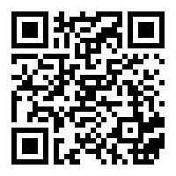
in the Council Chambers at City Hall
6:00 pm
https://www.youtube.com/@cityoffarmingtonil

