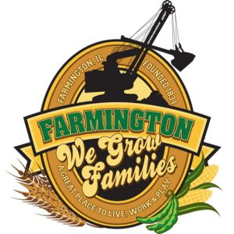
FARMINGTON CITY COUNCIL

AGENDA February 5, 2024
CITY COUNCIL CHAMBERS
Amended

6:00 P.M.
322 E. FORT STREET, FARMINGTON IL 61531

Call to Order
Pledge of Allegiance

Roll Call:

Minutes
Regular Session: January 15, 2024

Correspondence

Bills Presented for Payment

Balance of Accounts

TIF Report
CEDC recommendations – Nichols Demo

Police Department Report
Swearing in of full-time Officer Ulm
Flock Cameras

Old Business

Discussion/Possible Action: Ordinance 2024-1 An ordinance approving and authorizing the execution of a TIF redevelopment agreement by and between the City of Farmington and Farmington Forward – 99 E Vernon Demo

New Business

Discussion/Possible Action: City Hall flooring quote
Discussion/Possible Action: City Hall Window quote
Discussion/Possible Action: City Hall flooring quotes
Discussion/Possible Action: Purchase of salt spreader $4,300

Committee Reports

Finance/Ordinance: Crusen Streets/Sidewalks/Garbage: Gilles
Public Safety: Boggs Parks and Recreation: Smith
Sewer: Fleming Public Grounds and Buildings: Rose

General Comments
Adjournment
https://www.youtube.com/@cityoffarmingtonil

