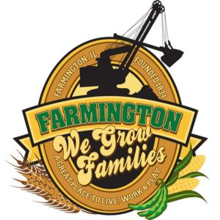
FARMINGTON CITY COUNCIL

AGENDA February 19, 2024
CITY COUNCIL CHAMBERS

6:00 P.M.
322 E. FORT STREET, FARMINGTON IL 61531

Call to Order
Pledge of Allegiance

Roll Call

Minutes
Regular Session: February 5, 2024

Correspondence

Cemetery Minutes

Old Business
Discussion/Possible Action: Flock Cameras

NEW BUSINESS:

Discussion/Possible Action: Farmington TIF District/2022 Payable 2023 School District Reimbursement
Discussion/Possible Action: Koala Easter Egg Donation

COMMITTEE REPORTS

Finance/Ordinance: Crusen Streets/Sidewalks/Garbage: Gilles
Public Safety: Boggs Parks and Recreation: Smith
Sewer: Fleming Public Grounds and Buildings: Rose

GENERAL COMMENTS
ADJOURNMENT
https://www.youtube.com/@cityoffarmingtonil

