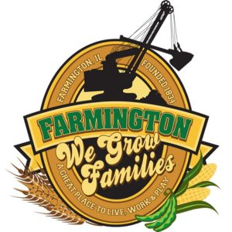
FARMINGTON CITY COUNCIL

AGENDA
CITY COUNCIL CHAMBERS
Febriary 17, 2025
6:00 P.M.
322 E. FORT STREET, FARMINGTON IL 61531

Call to Order
Pledge of Allegiance

Roll Call

Minutes
Regular Session:

Correspondence

Cemetery Minutes

Old Business

New Business

- Discussion/Possible Action: Ordinance 2025-01 An Ordinance to Vacate South Sunny Street Located Adjoining Property Owned by Lozier Oil Company
- Discussion/Possible Action: Ordinance 2025-02 An Ordinance Approving the Acquisition of Certain Real Estate from Cramer Rd. Developers, LLC
- Discussion/Possible Action: Ordinance 2025-03 An Ordinance Approving and Authorizing the Execution of a TIF Redevelopment agreement by and between the City of Farmington, Fulton County, IL and Dana Cardenas and Mi Casa Farmington, LLC
- Discussion/Possible Action: Ordinance 2025-04 An Ordinance Approving and Authorizing the Execution of a TIF Redebelopment Agreement by and between the City of Farmingtonm Fulton County, IL and Scott Anderson DBA Subway
- Discussion/Possible Action Ordinance 2025-05 AN ORDINANCE APPROVING THE RECOMMENDATIONS OF THE CITY OF FARMINGTON PLANNING COMMISSION AND AMENDING TITLE 10 OF THE CITY OF FARMINGTON CODE TO ADOPT THE SOLAR INSTALLATIONS ORDINANCE AS SECTION 10-16-1.

Committee Reports:

Finance/Ordinance: Ald. Crusen Streets/Sidewalks/Garbage: Ald. Gilles
Public Safety: Ald. Boggs Parks and Recreation: Ald. Smith
Sewer: Ald. Fleming Public Grounds and Buildings: Ald. Rose

General Comments

Adjournment

https://www.youtube.com/@cityoffarmingtonil

