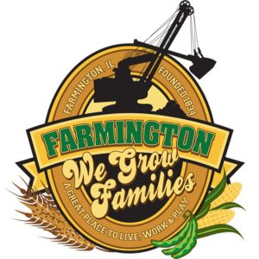
FARMINGTON CITY COUNCIL

AGENDA December 4, 2023
CITY COUNCIL CHAMBERS
Amended

7:00 P.M.
322 E. FORT STREET, FARMINGTON IL 61531

Call to Order
Pledge of Allegiance

Roll Call:

PUBLIC HEARING ON 23-24 ANNUAL BUDGET ORDINANCE

Minutes
Regular Session: November 20, 2023

Correspondence
Kent McDowell/Salvation Army Bell Ringing Opportunities

Bills Presented for Payment

Balance of Accounts

TIF Report

Police Department Report
Flock Cameras

Old Business

Discussion/Possible Action: Building Updates/Roof Solar
Discussion/Possible Action: Diva Roof Ordinance update

New Business

Discussion/Possible Action: Budget Hearing
Discussion/Possible Action: Possible low interest loan for building project
Discussion/Possible Action: An Ordinance regarding the Illinois Paid Leave for all Workers Act for the COF
Discussion/Possible Action: 2024 Council Meetings to be at 6

Committee Reports

Finance/Ordinance: Crusen Streets/Sidewalks/Garbage: Gilles
Public Safety: Boggs Parks and Recreation: Smith
Sewer: Fleming Public Grounds and Buildings: Rose

General Comments
Adjournment
https://www.youtube.com/@cityoffarmingtonil

