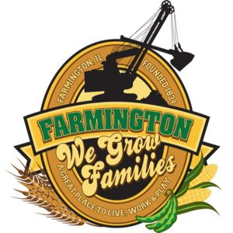
FARMINGTON CITY COUNCIL

AGENDA
CITY COUNCIL CHAMBERS
7:00 P.M.322 E. FORT STREET, FARMINGTON IL 61531
December 18, 2023

Call to Order
Pledge of Allegiance

Roll Call

Minutes
Regular Session:

Correspondence

Cemetery Minutes

Old Business

- Discussion/Possible Action: An Ordinance regarding the Illinois Paid Leave for all Workers Act for the COF
- Discussion/Possible Action: Building Updates/Roof Solar

New Business

Committee Reports:

Finance/Ordinance: Ald. Crusen Streets/Sidewalks/Garbage: Ald. Gilles
Public Safety: Ald. Boggs Parks and Recreation: Ald. Smith
Sewer: Ald. Fleming Public Grounds and Buildings: Ald. Rose

General Comments

Adjournment

