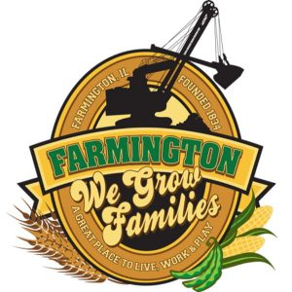
FARMINGTON CITY COUNCIL

AGENDA
CITY COUNCIL CHAMBERS
December 16, 2024
6:00 P.M.
322 E. FORT STREET, FARMINGTON IL 61531

Call to Order
Pledge of Allegiance

Roll Call

Minutes
Regular Session: 12-2-2024

Correspondence

Cemetery Minutes

Admin Report

Old Business

New Business

- Discussion/Possible Action: Ordinance 2024-20 An Ordinance Adopting to Ammend the Annual Budget of the City of Farmington for the Fiscal Year Beginning May 1, 2024, and Ending April 30, 2025
- Discussion/Possible Action: Ordinance 2024-21 An Ordinance Adopting Levying and Assessing Taxes for the Fiscal Year Beginning May 1, 2024, and Ending April 30, 2025, of the City of Farmington, Peoria County, Fulton County and State of Illinois
- Discussion/Possible Action: CEDC Recommendations
- Discussion: Solar Permits

Committee Reports:

Finance/Ordinance: Ald. Crusen Streets/Sidewalks/Garbage: Ald. Gilles
Public Safety: Ald. Boggs Parks and Recreation: Ald. Smith
Sewer: Ald. Fleming Public Grounds and Buildings: Ald. Rose

General Comments

Adjournment

