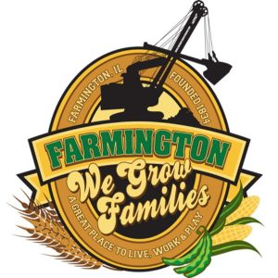
FARMINGTON CITY COUNCIL
December 15, 2025
AGENDA
CITY COUNCIL CHAMBERS
6:00 P.M.
322 E. FORT STREET, FARMINGTON IL 61531

Call to Order
Pledge of Allegiance

Roll Call

Minutes
Regular Session: 12-1-25

Correspondence

Cemetery Minutes

Old Business

New Business

- Discussion/Possible Action: CEDC Recommandations
- Discussion/Possible Action : Approval to hire a new Full Time Officeer
- Swearing in a new Full Time Officer
- Discussion/Possible Action : Ordinance 2025-35 An Ordinance Authorizing the sale of 165 N Wall
- Discussion/Possible Action: IDOT Joint Agreement for IL 78 repaving

Committee Reports:

Finance/Ordinance: Ald. Crusen Streets/Sidewalks/Garbage: Ald. Gilles
Public Safety: Ald. Boggs Parks and Recreation: Ald. Smith
Sewer: Ald. Fleming Public Grounds and Buildings: Ald. Rose

General Comments

Adjournment

