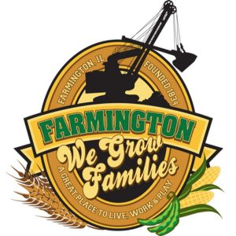
FARMINGTON CITY COUNCIL

AGENDA
CITY COUNCIL CHAMBERS
6:00 P.M.
322 E. FORT STREET, FARMINGTON IL 61531

Call to Order
Pledge of Allegiance

Roll Call:

Minutes
Regular Session: 11-17-25

Correspondence

Bills Presented for Payment

Balance of Accounts

Police Department Report

Old Business

- Discussion/Possible Action: Road Use Agreement with SoLAmercia Energy for Peterson Solar Project

New Business

Executive Session:

THE APPOINTMENT, EMPLOYMENT, COMPENSATION, DISCIPLINE, PERFORMANCE OR DISMISSAL OF SPECIFIC EMPLOYEES OF THE PUBLIC BODY OR LEGAL COUNCIL FOR THE PUBLIC BODY, INCLUDING HEARING TESTIMONY ON A COMPLAINT LODGED AGAINST AN EMPLOYEE OF THE PUBLIC BODY OR AGAINST LEGAL COUNSEL FOR THE PUBLIC BODY TO DETERMINE ITS VALIDITY

- Discussion/Possible Action: Action resulting from Executive Session
- Discussion/Possible Action: Ordinance 2025-33 An Ordinance Levying and Assessing Property Taxes 2025-2026
- Discussion/Possible Action: Ordinance 2025-34 An Ordinance Requiring Right-of-Way Opening Application for any Construction Project
- Discussion/Possible Action: Donation to Christmas Hope Chest
- Discussion/Possible Action: Purchase of 71, 77, and 85 E. Fort St.

Committee Reports

Finance/Ordinance: Crusen Streets/Sidewalks/Garbage: Gilles
Public Safety: Boggs Parks and Recreation: Smith
Sewer: Fleming Public Grounds and Buildings: Rose

General Comments
Adjournment

