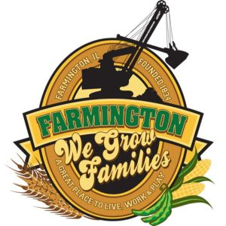
FARMINGTON CITY COUNCIL
November 3, 2025
AGENDA
CITY COUNCIL CHAMBERS
6:00 P.M.
322 E. FORT STREET, FARMINGTON IL 61531

Call to Order
Pledge of Allegiance

Roll Call:

Minutes
Regular Session: 10-20-25

Correspondence

Bills Presented for Payment

Balance of Accounts

Police Department Report

Old Business
- Discussion/Possible Action: Ordinance 2025-21 NON TIF Residential Redevelopment Grants for FY26

New Business
- Discussion/Possible Action : Computer Replacent Police Department
- Discussion/Possible Action : Computer Replacement City Offices
- Discussion/Possible Action: Annual Tax Levy Estimate
- Discussion/Possible Action: Santa Bounce Donation
- Discussion: One way street for South Freemont Street and South Gold Street

Committee Reports

Finance/Ordinance: Crusen Streets/Sidewalks/Garbage: Gilles
Public Safety: Boggs Parks and Recreation: Smith
Sewer: Fleming Public Grounds and Buildings: Rose

General Comments
Adjournment
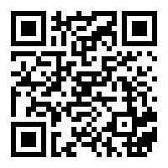
https://www.youtube.com/@cityoffarmingtonil

