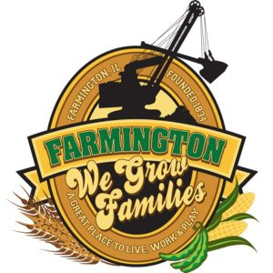
FARMINGTON CITY COUNCIL

AGENDA November 20, 2023
CITY COUNCIL CHAMBERS

7:00 P.M.
322 E. FORT STREET, FARMINGTON IL 61531

Call to Order
Pledge of Allegiance

Roll Call

Minutes
Regular Session: November 6, 2023

Correspondence

Cemetery Minutes

Public Works Report

Old Business
Discussion/Possible Action: CEDC Recommendations
Discussion/Possible Action: Sovia Home/Cassandra Anderson Agreement
Discussion/Possible Action: Fire Department TIF Agreement

NEW BUSINESS:

Discussion/Possible Action: Legacy Solar
Discussion/Possible Action: Christmas Bonus for Employees
Discussion/Possible Action: End Lease with Farmington/Canton Family YMCA

COMMITTEE REPORTS

Finance/Ordinance: Crusen Streets/Sidewalks/Garbage: Gilles
Public Safety: Boggs Parks and Recreation: Smith
Sewer: Fleming Public Grounds and Buildings: Rose

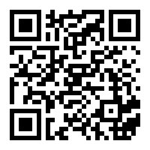
GENERAL COMMENTS
ADJOURNMENT
https://www.youtube.com/@cityoffarmingtonil

