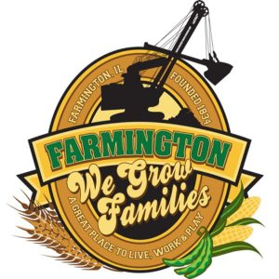
FARMINGTON CITY COUNCIL

AGENDA
CITY COUNCIL CHAMBERS
November 18, 2024
6:00 P.M.
322 E. FORT STREET, FARMINGTON IL 61531

Call to Order
Pledge of Allegiance

Roll Call

PUBLIC HEARING ON 24-25 ANNUAL BUDGET ORDINANCE

Minutes
Regular Session: 11-4-2024

Correspondence

Cemetery Minutes

Old Business

- Discussion/Possible Action: Purchase Flooring for the remainder of the South Hallway

New Business

- Discussion/Possible Action: Ordinance 2024-19 An Ordinance Adopting the Annual Budget of the City of Farmington for the Fiscal Year Beginning May 1, 2024, and Ending April 30, 2025
- Discussion/Possible Action: Wilson Street Expansion
- Discussion: Stop Sign at Short and East Vernon
- Discussion/Possible Action: Donation for Santa Bounce
- Discussion/Possible Action: Ordinance 2024-16 An Ordinance Approving and Authorizing the Execution of a TIF Redevelopment Agreement by and between the City of Farmington and David Sanders and Steve Thurman d.b.a. Diva Florist
- Discussion/Possible Action: Ordinance 2024-17 An Ordinance Approving and Authorizing the Execution of a First Amendment to the TIF Redevelopment Agreement by and between the City of Farmington and Dana Cardenas
- Discussion/Possible Action: Ordinance2024-18 An Ordinance Approving and Authorizing the Execution of a TIF Redevelopment Agreement by and between the City of Farmington and Walters’ Ag Service, Inc. and Julia Walters Edwards
- Discussion/Possible Action: Purchase of 2 Junior Backboards for Biddy Ball

Committee Reports:

Finance/Ordinance: Ald. Crusen Streets/Sidewalks/Garbage: Ald. Gilles
Public Safety: Ald. Boggs Parks and Recreation: Ald. Smith
Sewer: Ald. Fleming Public Grounds and Buildings: Ald. Rose

General Comments

Adjournment

