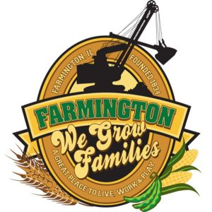
FARMINGTON CITY COUNCIL
October 20, 2025
AGENDA
CITY COUNCIL CHAMBERS

6:00 P.M.
322 E. FORT STREET, FARMINGTON IL 61531

Call to Order
Pledge of Allegiance

Roll Call

Minutes
Regular Session: 10-1-25

Correspondence

Cemetery Minutes

Old Business

New Business
- Discussion/Possible Action: Public Works Mower
- Discussion/Possible Action: Curb and Sidewalk Replacement
- Discussion: Code Enforcement Officer
- Discussion/Possible Action: Ordinance 2025-21 RE-Authorize FY26 Non Tif Residential Grants

Committee Reports:

Finance/Ordinance: Ald. Crusen Streets/Sidewalks/Garbage: Ald. Gilles
Public Safety: Ald. Boggs Parks and Recreation: Ald. Smith
Sewer: Ald. Fleming Public Grounds and Buildings: Ald. Rose

General Comments

Adjournment

