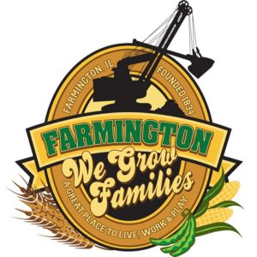
FARMINGTON CITY COUNCIL

AGENDA October 2, 2023
CITY COUNCIL CHAMBERS

7:00 P.M.
322 E. FORT STREET, FARMINGTON IL 61531

CALL TO ORDER:
PLEDGE OF ALLEGIANCE:

ROLL CALL:

MINUTES:
REGULAR SESSION: September 18, 2023

CORRESPONDENCE:
Officer Carlock Resignation
Farmington District 265 Homecoming Parade

BILLS PRESENTED FOR PAYMENT

BALANCE OF ACCOUNTS

TIF REPORT

POLICE DEPARTMENT REPORT:

OLD BUSINESS:

None

NEW BUSINESS:

Discussion/Possible Action: Upgrade LOCIS 8
Discussion/Possible Action: Recommendations CEDC
Discussion/Possible Action: Recommendations from Building and Grounds Committee Meeting
Discussion/Possible Action: Police Merit Commission Recommendations
Discussion/Possible Action: Purchase Drawer System for Police Squad Trucks
Discussion/Possible Action: First Reading, Ordinance 2023-16 Amending Nuisances.
Discussion/Possible Action: Sealcoat John Higgs Parking lot
Discussion/Possible Action: Setting Halloween Trick or Treating Hours

COMMITTEE REPORTS

Finance/Ordinance: Crusen Streets/Sidewalks/Garbage: Gilles
Public Safety: Boggs Parks and Recreation: Smith
Sewer: Fleming Public Grounds and Buildings: Rose

GENERAL COMMENTS
ADJOURNMENT
https://www.youtube.com/@cityoffarmingtonil

