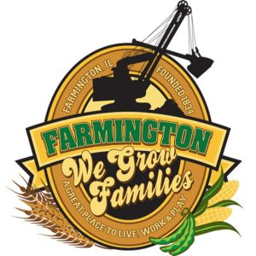
FARMINGTON CITY COUNCIL

AGENDA October 2, 2023
CITY COUNCIL CHAMBERS

7:00 P.M.
322 E. FORT STREET, FARMINGTON IL 61531

Call to Order
Pledge of Allegiance

Roll Call

Minutes
Regular Session: October 2, 2023

Correspondence

Cemetery Minutes

Public Works Report

Old Business

NEW BUSINESS:
Executive Session
(5ILCS 120/2) (C) (1)
THE APPOINTMENT, EMPLOYMENT, COMPENSATION, DISCIPLINE, PERFORMANE, OR DISMISSAL OF SPECIFIC EMPLOYEES OF THE PUBLIC BODY OR LEGAL COUNSEL FOR THE PUBLIC BODY, INCLUDING HEARING TESTIMONY ON A COMPLAINT LODGED AGAINST AN EMPLOYEE OF THE PUBLIC BODY OR AGAINST LEGAL COUNSEL FOR THE PUBLIC BODY TO DETERMINE ITS VALIDITY

Discussion/Possible Action from Executive Session
Discussion/Possible Action: Change in Employee Health Care Coverage
Discussion/Possible Action: Garbage Bids to City

COMMITTEE REPORTS

Finance/Ordinance: Crusen Streets/Sidewalks/Garbage: Gilles
Public Safety: Boggs Parks and Recreation: Smith
Sewer: Fleming Public Grounds and Buildings: Rose

GENERAL COMMENTS
ADJOURNMENT
https://www.youtube.com/@cityoffarmingtonil

