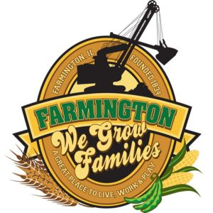
FARMINGTON CITY COUNCIL

AGENDA
CITY COUNCIL CHAMBERS
January 20, 2025
6:00 P.M.
322 E. FORT STREET, FARMINGTON IL 61531

Call to Order
Pledge of Allegiance

Roll Call

Minutes
Regular Session: 1-20-25 -

Correspondence
Graham Medical Evening in Red
Planning & Zoning Meeting 2/11 at 6 re: Solar
TIF 101 2/18 at 5:30

Cemetery Minutes

Admin Report

Old Business
Discussion: Stop sign at Elmwood Road and Vernon Street

New Business

- Discussion: JFL

Committee Reports:

Finance/Ordinance: Ald. Crusen Streets/Sidewalks/Garbage: Ald. Gilles
Public Safety: Ald. Boggs Parks and Recreation: Ald. Smith
Sewer: Ald. Fleming Public Grounds and Buildings: Ald. Rose

General Comments

Adjournment

https://www.youtube.com/@cityoffarmingtonil

