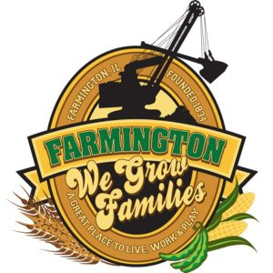
FARMINGTON CITY COUNCIL

AGENDA January 15, 2024
CITY COUNCIL CHAMBERS

6:00 P.M.
322 E. FORT STREET, FARMINGTON IL 61531

Call to Order
Pledge of Allegiance

Roll Call

Minutes
Regular Session: January 2, 2024

Correspondence
Italian Fest Public Meeting January 29 at 5:30, Council Chambers

Cemetery Minutes

Public Works Report

Old Business
Discussion/Possible Action:

NEW BUSINESS:

Discussion/Possible Action: PD New Hire Sign-on Bonus Structure
Discussion/Possible Action: FCC/Italian Fest Gaming Allocation

COMMITTEE REPORTS

Finance/Ordinance: Crusen Streets/Sidewalks/Garbage: Gilles
Public Safety: Boggs Parks and Recreation: Smith
Sewer: Fleming Public Grounds and Buildings: Rose

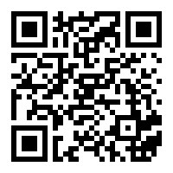
GENERAL COMMENTS
ADJOURNMENT
https://www.youtube.com/@cityoffarmingtonil

