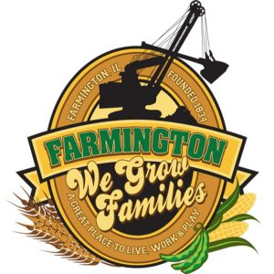
FARMINGTON CITY COUNCIL

AGENDA September 5, 2023
CITY COUNCIL CHAMBERS

7:00 P.M.
322 E. FORT STREET, FARMINGTON IL 61531

CALL TO ORDER
PLEDGE OF ALLEGIANCE

ROLL CALL

MINUTES
Regular Session 8-21-23

CORRESPONDENCE:
Knights of Colombus September 15 & 16

BILLS PRESENTED FOR PAYMENT

BALANCE OF ACCOUNTS

TIF REPORT

POLICE DEPARTMENT REPORT

OLD BUSINESS:

- Discussion/Possible Action: Thompson/Batterton Beer Garden

NEW BUSINESS:

- Discussion/Possible Action: CEDC Recommendations to City Council
- Discussion/Possible Action: Purchase Public Works Tools
- Discussion/Possible Action: Jacobs Park Bathroom Renovation

COMMITTEE REPORTS

Finance/Ordinance: Crusen Streets/Sidewalks/Garbage: Gilles
Public Safety: Boggs Parks and Recreation: Smith
Sewer: Fleming Public Grounds and Buildings: Rose

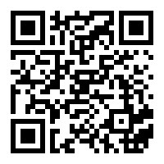
GENERAL COMMENTS
ADJOURNMENT
https://www.youtube.com/@cityoffarmingtonil

