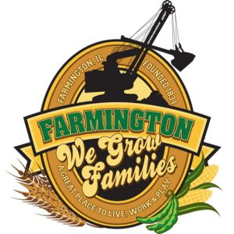
FARMINGTON CITY COUNCIL

AGENDA July 3, 2023
CITY COUNCIL CHAMBERS

7:00 P.M.
322 E. FORT STREET, FARMINGTON IL 61531

Call to Order
Pledge of Allegiance

Roll Call

Minutes
Regular Session: 6-19-23

Correspondence

Bills Presented for Payment

Working Cash Summary

TIF Report

Police Department Report

Old Business

- Discussion: First Reading Ordinance 2024-01 Whistle Blower Protection

New Business

- Discussion/Possible Action: Fate of Current Website
- Discussion/Possible Action: CEDC Recommendations to City Council
- Discussion/Possible Action: Chamber of Commerce Event closing East St. on 8-19-23

Committee Reports:

Finance/Ordinance: Ald. Crusen Streets/Sidewalks/Garbage: Ald. Gilles
Public Safety: Ald. Boggs Parks and Recreation: Ald. Smith
Sewer: Ald. Fleming Public Grounds and Buildings: Ald. Rose

General Comments

Adjournment

