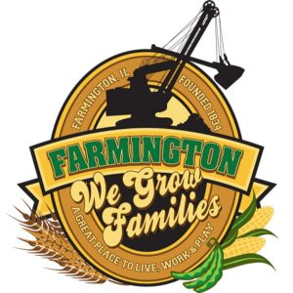
FARMINGTON CITY COUNCIL

AGENDA JUNE 19, 2023
CITY COUNCIL CHAMBERS

7:00 P.M.
322 E. FORT STREET, FARMINGTON IL 61531

Call to Order
Pledge of Allegiance

Roll Call

Minutes
Regular Session: 6-5-23

Correspondence
Dave Ehlers Resignation

Cemetery Minutes

Streets Department Report

Old Business

New Business
- Executive Session
(5ILCS 120/2) (C) (1)
THE APPOINTMENT, EMPLOYMENT, COMPENSATION, DISCIPLINE, PERFORMANE, OR DISMISSAL OF SPECIFIC EMPLOYEES OF THE PUBLIC BODY OR LEGAL COUNSEL FOR THE PUBLIC BODY, INCLUDING HEARING TESTIMONY ON A COMPLAINT LODGED AGAINST AN EMPLOYEE OF THE PUBLIC BODY OR AGAINST LEGAL COUNSEL FOR THE PUBLIC BODY TO DETERMINE ITS VALIDITY

- Discussion/Possible Action from Executive Session
- Discussion/Possible Action on Mayoral Appointment
- Discussion/Possible Action: Out of District TIF Ordinance

Committee Reports:

Finance/Ordinance: Ald. Crusen Streets/Sidewalks/Garbage: Ald. Gilles
Public Safety: Ald. Boggs Parks and Recreation: Ald. Smith
Sewer: Ald. Fleming Public Grounds and Buildings: Ald. Rose

General Comments

Adjournment

