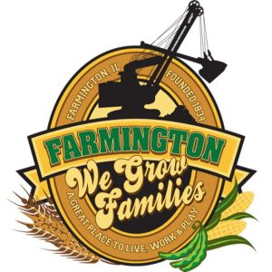
FARMINGTON CITY COUNCIL

AGENDA JUNE 5, 2023
CITY COUNCIL CHAMBERS

7:00 P.M.
322 E. FORT STREET, FARMINGTON IL 61531

Call to Order
Pledge of Allegiance

Roll Call

Minutes
Regular Session: 5-19-23

Correspondence
Thank you - Jace Crawford
Resignation - Steven Peters

Bills Presented for Payment

Working Cash Summary

TIF Report

Police Department Report

Old Business

- Discussion/Possible Action: Batterton Beer Garden

New Business
- Executive Session
(5ILCS 120/2) (C) (1)
THE APPOINTMENT, EMPLOYMENT, COMPENSATION, DISCIPLINE, PERFORMANE, OR DISMISSAL OF SPECIFIC EMPLOYEES OF THE PUBLIC BODY OR LEGAL COUNSEL FOR THE PUBLIC BODY, INCLUDING HEARING TESTIMONY ON A COMPLAINT LODGED AGAINST AN EMPLOYEE OF THE PUBLIC BODY OR AGAINST LEGAL COUNSEL FOR THE PUBLIC BODY TO DETERMINE ITS VALIDITY

- Discussion/Possible Action from Executive Session
- Discussion/Possible Action on Mayoral Appointment
- Discussion/Possible Action: CEDC Recommendations to City Council
- Discussion/Possible Action: City Web Site
- Discussion/Possible Action: FFA Donation
- Discussion/Possible Action: Fireworks Donation
- Discussion/Possible Action: Farmington Chamber of Commerce 4th of July Celebration.

Committee Reports:

Finance/Ordinance: Ald. Crusen Streets/Sidewalks/Garbage: Ald. Gilles
Public Safety: Ald. Boggs Parks and Recreation: Ald. Smith
Sewer: Ald. Fleming Public Grounds and Buildings: Ald. Rose

General Comments

Adjournment

