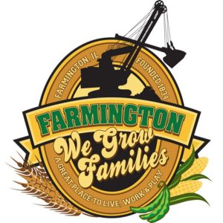
FARMINGTON CITY COUNCIL

CITY COUNCIL CHAMBERS
February 3, 2025
6:00 P.M.
322 E. FORT STREET, FARMINGTON IL 61531

Call to Order
Pledge of Allegiance

Roll Call:

Minutes
Regular Session: 1-20-25

Correspondence

Bills Presented for Payment

Balance of Accounts

TIF Report

Police Department Report

Old Business

New Business
Possible Discussion/Action: CEDC Recommendations
Discussion: Ordinance to Vacate Sunny Street

Committee Reports

Finance/Ordinance: Crusen Streets/Sidewalks/Garbage: Gilles
Public Safety: Boggs Parks and Recreation: Smith
Sewer: Fleming Public Grounds and Buildings: Rose

General Comments
Adjournment

https://www.youtube.com/@cityoffarmingtonil

